**DB Tablolar ve SQL Sorgular**

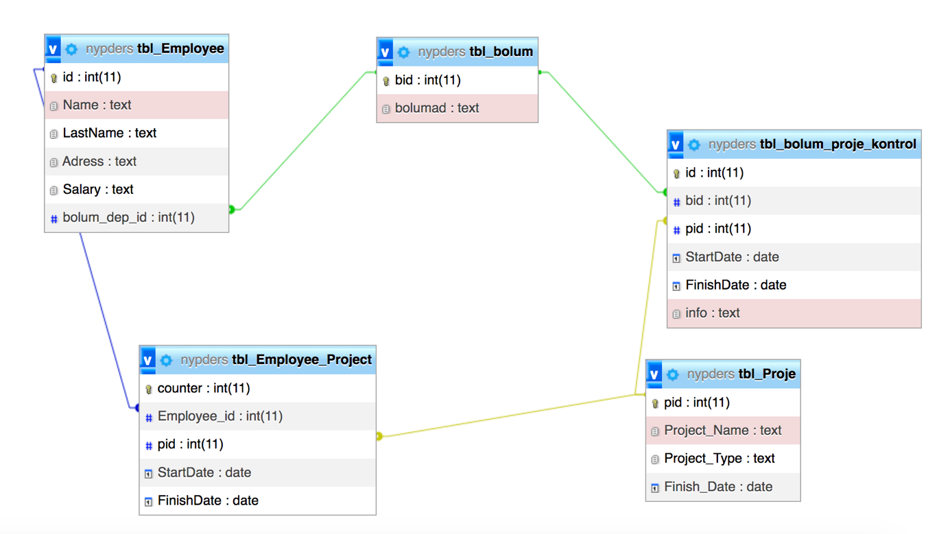

Bölüm Tablosu

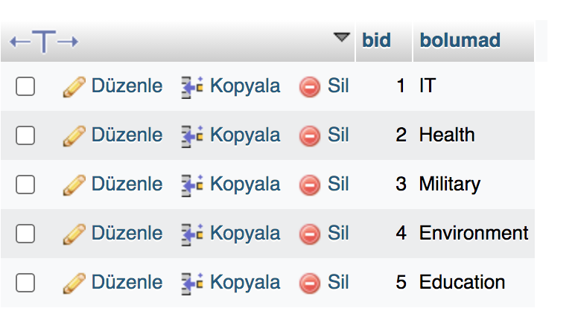

Bolüm Proje Kontrol Tablosu

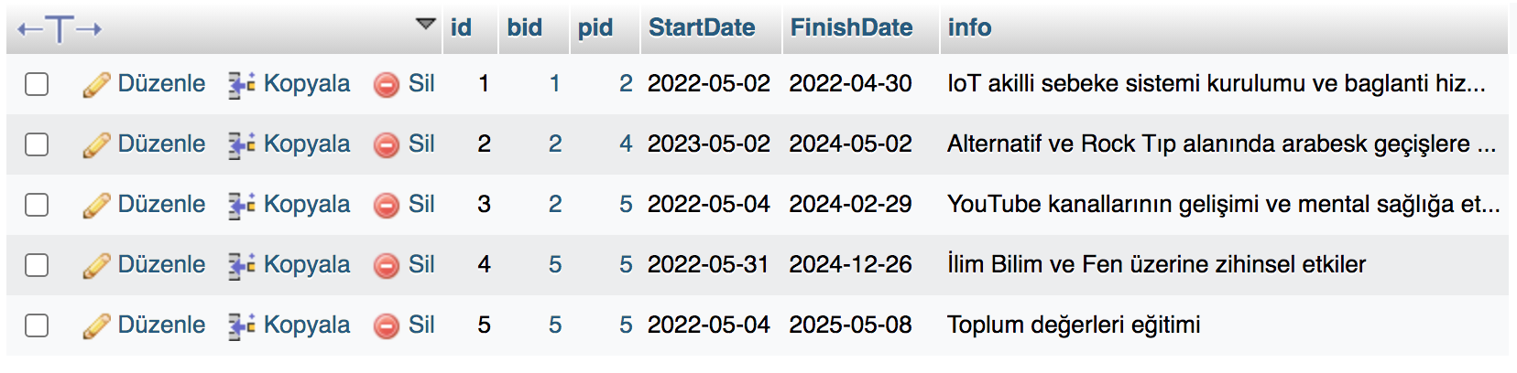

Tbl_Employee

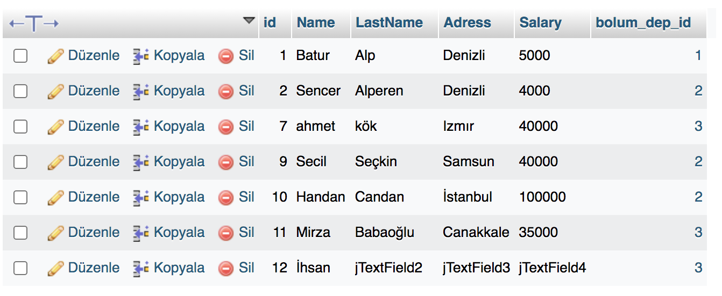

Tbl_Employee_Project

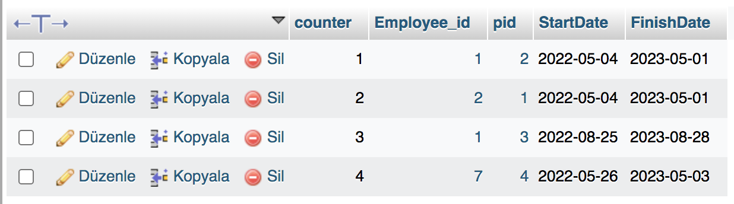

Tbl_Proje

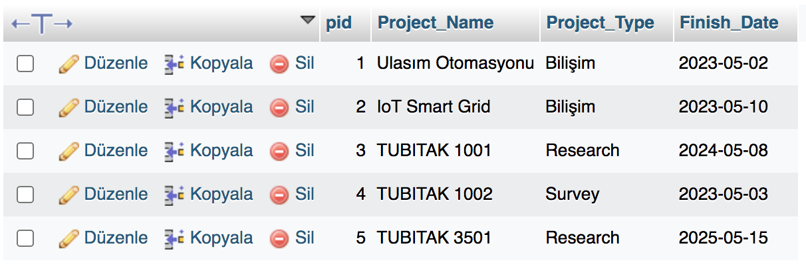

[SELECT](http://localhost/phpmyadmin/url.php?url=https://dev.mysql.com/doc/refman/8.0/en/select.html) * FROM `tbl_Proje` WHERE Finish_Date<'2023-05-10';

COUNT

Çalışan sayısı

SELECT COUNT(*) FROM `tbl_Employee`

Denizlili Çalışan sayısı

SELECT COUNT(*) FROM `tbl_Employee`

WHERE Adress='Denizli'

Maaşı 4000 50000 arasından olan çalışan sayısı

SELECT COUNT(*) FROM `tbl_Employee`

WHERE Salary

BETWEEN 4000 AND 50000

IN Where sonrası çok değer girmeye yarar, Or gibi çalışır. Çalışan tablosunda adres Izmir yada Denizli olanları getir.

SELECT * FROM `tbl_Employee`

WHERE Adress IN ('Denizli', 'Izmır')

SELECT * FROM `tbl_Employee`

WHERE Adress NOT IN ('Denizli', 'Izmır')

SELECT * FROM `tbl_Employee`

WHERE Adress

**LIKE** 'D%'

Alternatifleri deneyin '%e' '%e%'

INSERT INTO `tbl_Employee`( `Name`, `LastName`, `Adress`, `Salary`, `bolum_dep_id`) VALUES ('Merve','Metin','Canakkale','45000','3');

Adresi denizli veya maaşı 40000 den fazla olan çalışanlar

select * from tbl_Employee where Adress='Denizli' OR salary>40000

Çalışanların bölüm id leri/kaç bölüm var

select DISTINCT bolum_dep_id from tbl_Employee

**ANY**

SELECT info

FROM tbl_bolum_proje_kontrol

WHERE pid = ANY (SELECT pid FROM tbl_Proje WHERE Project_Type='Research');

SELECT info

FROM tbl_bolum_proje_kontrol

WHERE bid = ANY (SELECT bid FROM tbl_bolum WHERE bolumad='Education');

select Project_Name, Project_Type from tbl_Proje where EXISTS(select pid from tbl_Employee_Project WHERE pid=tbl_Proje.pid)

<https://www.w3schools.com/sql/sql_join.asp>

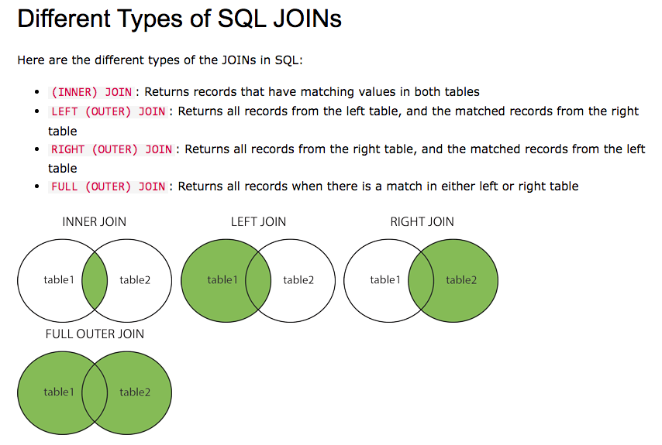

INNER JOIN

SELECT *

FROM tbl_Employee

INNER JOIN tbl_bolum_proje_kontrol

ON tbl_Employee.bolum_dep_id=tbl_bolum_proje_kontrol.bid

SELECT tbl_Employee.**Name**,tbl_Employee.**LastName**, tbl_Employee.**bolum_dep_id**, tbl_bolum_proje_kontrol**.bid**,tbl_bolum_proje_kontrol.**info**,tbl_bolum_proje_kontrol.**StartDate**

FROM tbl_Employee

**INNER JOIN** tbl_bolum_proje_kontrol

ON tbl_Employee.bolum_dep_id=tbl_bolum_proje_kontrol.bid

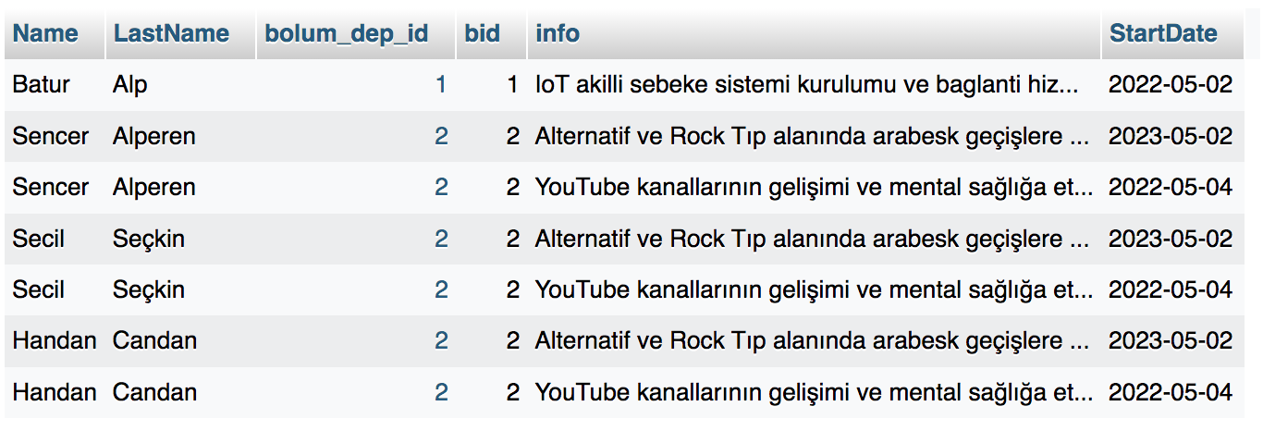

SELECT table1.column1,table1.column2,table2.column1,....

FROM table1

LEFT JOIN table2

ON table1.matching_column = table2.matching_column;

------

SELECT *

FROM tbl_Employee

**LEFT JOIN** tbl_bolum

ON tbl_Employee.bolum_dep_id=tbl_bolum.bid

ORDER BY tbl_Employee.id DESC

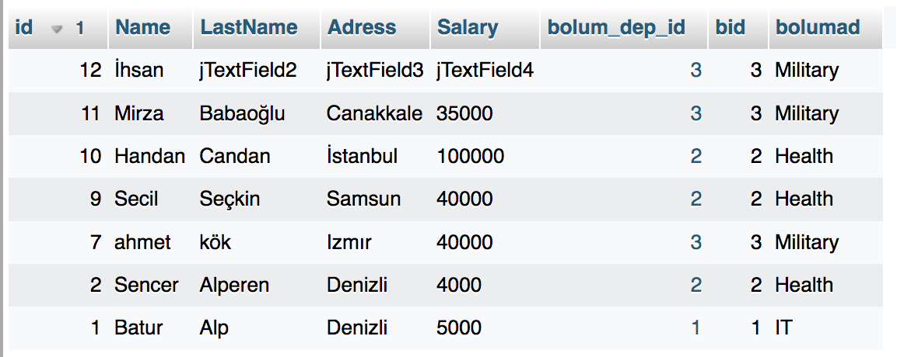

SELECT *

FROM tbl_Employee

**RIGHT JOIN** tbl_bolum

ON tbl_Employee.bolum_dep_id=tbl_bolum.bid

ORDER BY tbl_bolum.bid DESC

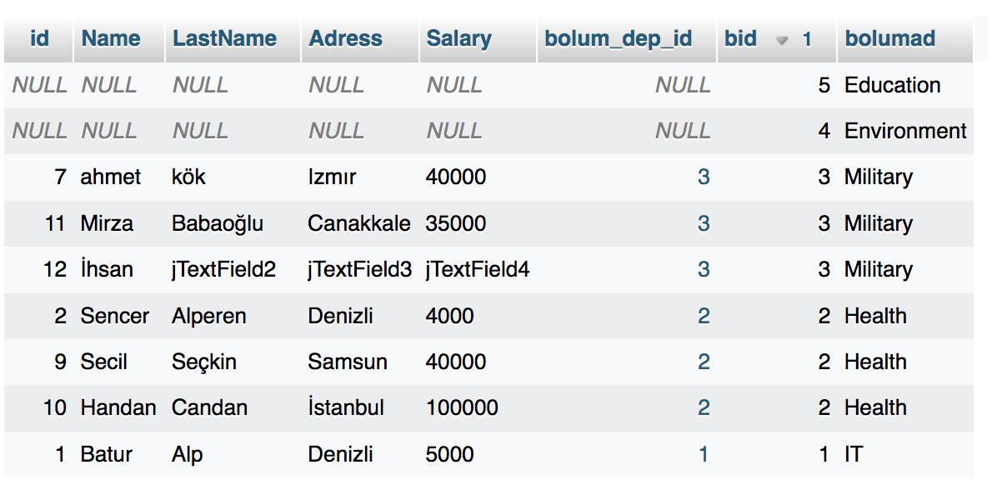

SELECT *

FROM tbl_Proje

CROSS JOIN tbl_Employee;

SELECT *

FROM tbl_Employee_Project

CROSS JOIN tbl_Proje

WHERE tbl_Employee_Project.pid=tbl_Proje.pid

